Health Care Chatbot allows the users to chat with the bot for health related questions. There is a lack of high-quality data in the domain of health care to develop the chatbot. The dataset that we have used to develop this solution is the Counsel Chat dataset available on the Kaggle. <https://www.kaggle.com/datasets/ssp1411/counsel-chat>

On the counsel chat forum there are 31 topics, with the number of posted responses ranging from “depression” to “anxiety”.

The counsel chat dataset has 9 columns described below:

1. questionID — A distinct question identifier
2. questionTitle — The title of the question
3. questionText — The body of the question
4. questionLink — A URL to the question description
5. topic — The topic the question
6. therapistName — The name of the therapist
7. therapistURL — The url of the therapist
8. answerText — The response of the therapist
9. upvotes — The number of upvotes on the answer.

The following bar plot shows the distribution of the topics in the dataset.

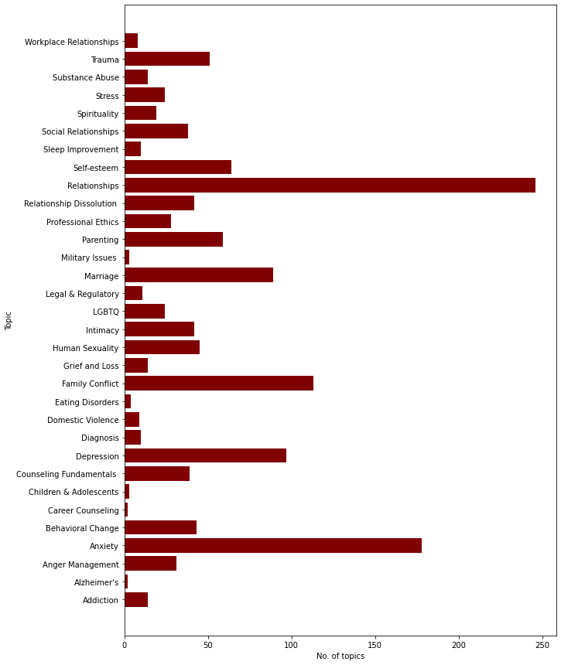

We filtered the dataset by selecting only the columns questionTitle, questionText, answerText, and topics.

For this project, we used the Bidirectional Encoder Representations from Transformers (BERT) model to get the embeddings from the query, question, and answer. The vocabulary size of the BERT is 30522 words.

We generate the embeddings of the question, and answers from the dataset. We do the padding on the embeddings to maintain the same shape.

We build the model using the first layer as the Embedding layer of size 128. The second layer is the bidirectional LSTM (Long Short Term Memory) layer with a dropout of 75%, the third layer is the bidirectional LSTM (Long Short Term Memory) layer with the dropout of 75%. The last layer is a dense layer with 16 units. The loss function is categorical cross entropy, the optimizer is Adam (Adaptive Moment Estimation), and metrics as accuracy, and precision. The following is the summary of our model with 4.5 million trainable parameters:

Model: "sequential_2"

_________________________________________________________________

Layer (type) Output Shape Param #

=================================================================

embedding_2 (Embedding) (None, 128, 128) 3906816

bidirectional_4 (Bidirectio (None, 128, 256) 263168

nal)

dropout_4 (Dropout) (None, 128, 256) 0

bidirectional_5 (Bidirectio (None, 256) 394240

nal)

dropout_5 (Dropout) (None, 256) 0

dense_2 (Dense) (None, 16) 4112

=================================================================

Total params: 4,568,336

Trainable params: 4,568,336

Non-trainable params: 0

We then train the model with 15 epochs and achieved the following results with the accuracy as 12% and precision as 98%:

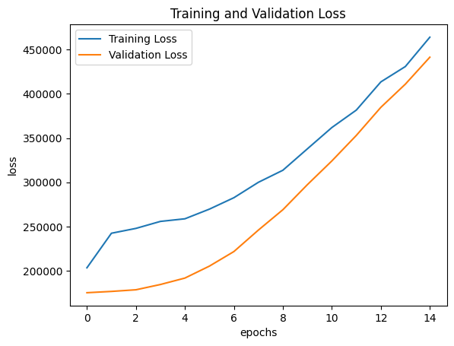

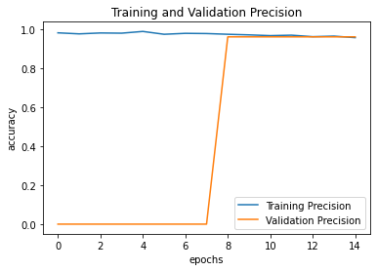

We wrote the real-time answer prediction bot that returns the answer based on the query. For example, we provided the following query:

*The Underlying Causes of Being Possessive*

Then we received the following response from the bot:

*<p>Hi there. Being 15 years old can be a very difficult time in your teenage life. I remember when I was 15 and how I often felt my parents weren’t listening to me. It’s even more difficult when you feel that you do not have a friend that you can confide in. </p><p>Having depression in the past and being able to get through it shows me that you can get through anything! Depression alone is a very difficult problem to work through. In addition to the communication problem with your parents, it appears that you are also struggling with stress and anxiety. We all have stress and anxiety in our lives. If we didn’t, none of us would be living. Anxiety &amp; stress keep us on our toes! Often, I have to remind myself of this as well. However, it is how we manage stress and anxiety, so it will not overcome our lives. </p><p>Are you familiar with relaxation techniques, such as: deep breathing exercises, meditation or yoga? Relaxation Techniques can help you tremendously in reducing your stress and anxiety. </p><p>Deep breathing exercises are helpful when you are on the go, such as school, shopping, out with friends or whatever extracurricular activities you engage in. Most people do not take full advantage of their lung capacity. I know, that sounds silly. But, it’s true. You would be surprised how much air you lungs can hold. Imagine being in the Doctor’s office and taking deep breaths. This is what you want to do when you are feeling overwhelmed and/or stressed. Take a moment to take in at least 10 deep breaths and let them out slowly. You will be surprised how well you feel afterwards. </p><p>Meditation and Yoga are also healthy forms to working through stress and anxiety. You will need a quiet place for your meditation. You want to be “in the moment” and take in the peace and serenity. All it takes is a quiet place, closing your eyes and thinking of your “happy place.” Some people use meditation music as well. If you have access to this type of music and or the internet for more ways to practice meditation, please go for it! </p><p>Yoga on the other hand will take a little more work and practice. I would not suggest you learning this on your own, if you have never attempted yoga before. Find an experienced Yoga instructor to teach you the ropes and/or ask your school counselor about the possibility of getting someone to come to the school to teach the students. </p><p>Lastly, in regards to your parents it is very important to be able to have a relationship where you feel comfortable communicating. I would recommend writing a letter to them, if you are unable to express how you feel in person. A letter is more intimate and requires a little more effort on their end. If they are open on working on this relationship, maybe suggest family counseling to fully work on this issue.</p><p> I hope this was helpful for you and I wish you the best! </p>*